V 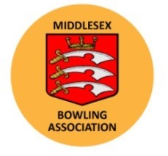

White Rose Trophy Squad Announcement

Hampshire Under 25’s v Middlesex Under 25’s
Sunday 2nd June, 1030hrs – Bannister Park BC, Eastleigh

Team Manager Howie Shearing is delighted to confirm that the following side has been selected to play Hampshire in this prestigious competition.

Josh Harwood (Masonian)
Freddie Hawes (North Greenwich)
Robbie Carter Jnr (Poplar)
Ollie Shearing (North Greenwich)

Kai Matthews (Staines)
Marcus Ryan (Paddington)
James Lewington (Ladygate, Captain)
Josh Clark (North London)

Kai Matthews makes his debut replacing Jack Fisher who is taking a year out. Team Captain James feels this is the strongest side since the Alfie Hill / Glen Adams days but with four of the side in their final year can they prevail and beat a strong Hampshire outfit on their own turf.

Supporters will be welcomed as the youngsters look to progress to the next round.

