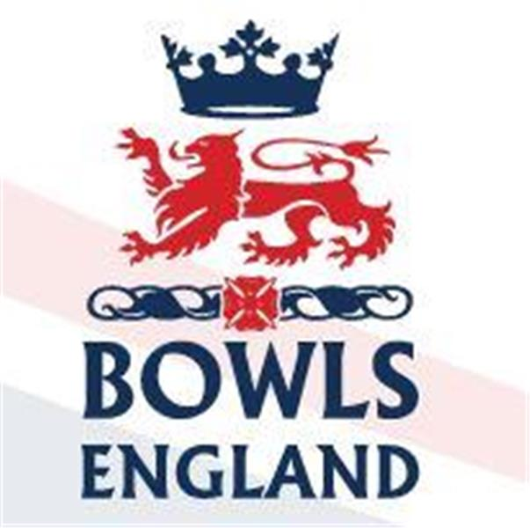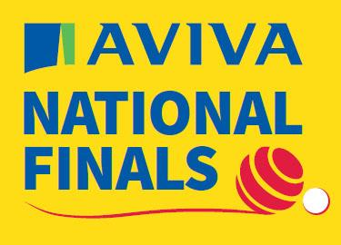
10th August to 27th August 2023 – Leamington Spa, Warwickshire.

Day 12 Review

Oh my, where do I start reviewing today’s events!

Ladies Singles

Round 2 of the Ladies Singles and Cathy Taylor from Cambridge Park had to play Suzanne King of Norfolk BC.

Cathy started really well and quickly led 5-0. Suzanne pulled a little back but Cathy stayed in front, 7-4 at the next update, then 9-7. There was a pause in the portal updates and when the next news came though Cathy had moved 17-12 ahead. Again Suzanne fought back and made it 17-17. On the next end Suzanne was holding shot but with her last bowl Cathy played a couple of feet over, removed the Norfolk Bowl and scored 3. On the very next end Cathy drew a couple of feet short with her first bowl and bettered it with her 2nd and 3rd. Suzanne sent her last bowl up looking to save game but it was just wide. Cathy is through 21-17.

Elsewhere in round 2 there are some quickfire wins. Hannah Smith of Wellington, Herefordshire wins 21-3, Annalisa Dunham wins 21-4, more on her shortly, Liz Smerdon puts Tonia Gann’s efforts into perspective by beating the talented Penny Cresswell from Poole Park, Dorset 21-2 and Val Osmond of Henleaze, Gloucestershire wins 21-1. Fallers, Rachel Mackriell, Sue Evans and Teresa Newman.

Into the 3rd round and Cathy is to play Annalisa Dunham from Carters Park, Lincolnshire on A3. Annalisa is both a Junior and Senior International. Last season she won the National Fours title and previously has been a mixed pairs winner (2013), Junior Pairs (2008) and Junior Singles (both 2009 and 2011). This year she qualified in the triples, losing 1st rd and the fours where she got to the 3rd rd. Annalisa also qualified in the Champion of Champions and she won the title winning the final 21-5. In the Singles so far she had beaten Hazel Forster of Jarrow West End, Durham 21-9 and Truro’s Elizabeth Bray 21-4 as mentioned above.

Well Annalisa went off like a person who had some where to be. 4, 3 and then lying 4 Cathy needed to gain a foothold before the game had passed by in a flash. Cathy achieved that by drawing a lovely shot to make it 1-7. Cathy then took the game to Annalisa and before you knew it the score was 7-7. Cathy scored a 3 to lead but promptly dropped the same to bring the game back all square. Having shown Annalisa she was there to compete Cathy took the lead again to move 13-11 ahead. At 16-13, Cathy held shot, Annalisa could not remove it and Cathy moved to within one end of the Quarter Finals. Stunningly one end was all it took, a four, confirmed by measure meant that Cathy was through 21-13. Epic.

Elsewhere Stef Branfield, the 2021 Champion beat Liz Smerdon 21-9, Elaine Score of Essex County beat Val Osmond 21-15, Tina Broderick of Wellingborough, Northants won 21-9 over Hannah Smith but former Champion Kirsty Richards of Whitnash, Warwickshire went out 17-21 to Jayne Christie of Potten, Bedfrodshire.

Men’s Fours

Monday dawned bright and sunny and with Ashford four Luke Mann, Joe Lovett, Mark Smith and Matt Larman set for the Quarter finals. They would be up against Kenny Muir, Willy McGinn, Alan Muir and Alistair Melville from Corby Forest BC, Northamptonshire and they would be on A1, so streamed for the Nation to watch.

The Ashford lads took a 2 on the first end and quickly established a nice little lead. 11-3 up at 6 ends things were going well but over the next 2 ends Northants got 5 shots back. Middlesex picked up a useful 3 before Northants got another single, 14-9 at 10 ends. Northants hit back with a 3. Middlesex scored a double on the 12th before the Northants skip drew a great shot for a single. 16-13 at 13 ends.

Middlesex score another double and they had a handy 5 shot lead with 4 to play. Middlesex secured a single on the 15th before Northants killed the 16th, twice! Northants had no answer to the accurate drawing of the Ashford side and 2 ends later it’s all over 23-13 to Middlesex and onto the Semi finals.

The other quarters saw Royal Mail Cart, Lincolnshire beat Heaton Hall, Lancashire 20-11; Andrew Briden’s Gerrards Cross four recover from losing a 5 on the first end to beat Darlington Railway Athletic, Durham 22-10 but there will not be an all Gerrards Semi as Alan Prices Quartet lose 10-14 to Joe Dawson and his Leicestershire crew.

So the Semi’s. Firstly let’s deal with the other one! Michael Gomme, Tim Godman, Matthew Hyde and Andrew Briden from Gerrards Cross, Bucks faced Nick Wardle, Jonathan Green, Chris Moore and Joe Dawson from Kingsthorpe, Leicestershire. This was a clash between the 2023 triples winner, who were profiled for that event and the 2023 Pairs winners who were profiled for that event and the fact that they played Ladygate 1st rd. In the end this massively high profile game turned into a somewhat one sided event with Leicestershire cruising into the final 23-11.

So the main event on A5. The Ashford boys v Steve Hill, Harry Mycock, Dominic McVittie and Martin Spencer of Royal Mail Cart, Lincolnshire. Dominic is a past Junior International and Martin both a Junior and Senior International. Martin won the Junior Singles in 2012 and the pairs in 2017. He was also mixed fours runner up in 2019. This season Martin had also qualified in the singles losing 20-21 1st rd. To get to the Semi’s they had beaten Perry Martin’s Boscmobe Cliff 20-14, Glenn William’s Garston 15-14, Thurlton, Suffolk also 15-14 and Lancashire 20-11.

Now for those who follow facebook there is a superb blow by blow account of the game by Martin Cory on the Bowls Middlesex Page plus footage of the action in the later stages. To summarise Middx lost the first end but after 3 led 4-1. They lost a 3 on the 5th end to trail 4-5 but it remained tight as can be up to half way where it was 7-7. Both sides were playing some superb bowls. Middlesex re took the lead on the 12th end and extended it to 13-9 after 14. On the 15th end Matt got 2 bad results with running bowls and Lincolnshire picked up 3. 13-12, 3 to go. Singles are exchanged and Middlesex go down the last end one up and one end from a National final.

Luke draws shot, Lincolnshire lead puts both bowls 18 inches or so behind. Joe is unlucky with his bowl as he hits Luke’s and turns it sideways. Lincolnshire take advantage and draw shot. Lincolnshire then hit their own shot but when the woods settle they probably lie 2. Mark just misses with his 2 draw attempts, fractions making a difference at this stage. Matt also misses with his first bowl and in response the Lincolnshire skip draws the shot about 6 inches short. Matt has to draw to lie game or at least get 2nd and hope an extra end comes his way but he misses with his attempt. Lincolnshire take 3 and win the Semi 14-16.

What an effort from Luke, Joe, Mark and Matt over 3 days. So close, yet as they say, so far from reaching a National final. Some superb performances though that the four can look back on with pride.

Ladies Senior Fours

In today’s prelim games Sue Bard Bodek’s Borough of Eye quartet went out 6-17 to a Potton four which is listed as including Jayne Christie who was in the Singles, not sure how she did that! Portishead RBL, Somerset beat Wellingborough 22-9 and Borough Green, Kent beat Dukeries, Notts 22-14.

The Senior fours timings are really weird as there were also early 1st rd games played today with Pershore, Worcestershire beating Sherwood Park, Warwickshire; Dunholme St Giles, Lincolnshire beating Plymouth City Bus, Devon and Bishop Monkton, Yorkshire beating Banbury Borough, Oxfordshire. Those 3 sides, plus Supermarine of Wiltshire who have a walkover now face only 1 game tomorrow and potentially only 1 on Wednesday before 2 on Thursday, could there not have been an evening session somewhere and condensed the event?

Men’s Senior Fours

Again there were 3 prelim ties with Plessey, Isle of Wight beating Blaby, Leicestershire; Gordon Charlton’s Sandwich side from Kent beat Wanstead Central from Essex 25-19 and finally it took an extra end to separate victors Camberley, Surrey from Wymondham Dell, Norfolk.

In the early 1st rd games Howard Watt’s Headington four from Oxfordshire beat Alec Atkinson’s Lancashire four in a heavyweight clash. Branston, Lincolnshire beat Tiverton Borough, Devon; Bromyard, Herefordshire beat Ramsey, Huntingdonshire and Ringwood, Hampshire pipped Bath, Somerset 17-16

Day 13 Preview

Ladies Singles

In the Quarter Finals Cathy takes on Rebecca Moorbey of Brampton, Hunts. Rebecca was the 2021 Champion and has a lengthy interview profiling her career to date in the Championship programme. Her Championship’s to date were profiled Saturday in relation to the mixed fours so I don’t propose to do them again! In the Singles she has played and beaten Alison Hall of Hatfield, Herts 21-4, Jacqueline Henderson of Long Eaton, Derbyshire 21-8 and Moira Parsons of Welford on Avon, Warwickshire 21-8. Clearly a young lady in form. This game WILL be at 0930 as scheduled.

In the other quarters Pa Walker of Birstall, Leicestershire takes on Stef Branfield of Clevedon, Somerset. Margaret Holden of Alton Social, Hampshire takes on Elaine Score of Essex County and Tina Broderick of Wellingborough, Northants takes on Jayne Christie of Potton, Beds.

Men’s Fours

It’s the final at 0930hrs on A1 and it’s between the 2 sides who put paid to Middlesex’s hopes. Steve Hill, Harry Mycock, Dominic McVittie and Martin Spencer from Royal Mail Cart BC, Lincolnshire will take on Nick Wardle, Jonathan Green, Chris Moore and Joe Dawson of Kingscroft, Leicestershire.

Ladies Senior Fours

Our four are Tina Cooper, Angela Cumine, Cathy Taylor and Ann Halliday from Cambridge Park. They take on Norfolk BC in the form of Carole Baker, Joyce Webster, Brenda Whitehead and Jackie Devitt.

This four were competition runners up in 2018. Brenda is also a former Senior International who was runner up in the 2013 2 woods. Jackie played in this year’s pairs and along with Carole was part of the 2016 fours runner up.

This game is delayed due to Cathy’s involvement in the main singles and is currently scheduled for 1330 on D4. One presumes though this will change further when Cathy knocks Rebecca out. Any potential 2nd rd tie will now take place at 0930hrs Wednesday which means Supermarine from Wiltshire have a free day tomorrow to watch bowls if they are already in the area!
The Senior Pairs winners from Cambridgeshire start their bid for the double when they play Frampton-on-Severn from Gloucestershire.

Men’s Senior Fours

Middlesex’s combatants are from Ladygate BC. Kevin Dwyer, Brian Shepperd, Steve Skinner and Dave Clements play on B3 at 0930 against Phil Sturman, Dave Wilde, Neil Clarke and Mark Sandoz from Gilt Edge BC, Worcestershire. This season Phil qualified in the pairs and fours, Neil the fours.

Victory for Ladygate will see them on D5 at 1330.

Dave Simpson, husband of everyone’s favourite Middlesex Umpire and now star of Bowls England streaming Mandy, plays in the Bucks Senior four from Gerrards Cross against Stenalees, Cornwall.

Men’s Junior Singles

Middlesex “B” Robbie Carter Jnr from Poplar BC was due to play his first round game at 1600hrs on B5 but he has received a walkover from his scheduled opponent George Rogan from Haltwhistle, Northumberland. So Robbie in straight into round 2 at lunchtime Wednesday.

Middlesex “A” is Ollie Shearing from North Greenwich BC, he plays on D4 at 1730 against Josh Phillips from Redland Green, Gloucestershire. Victory would also see Ollie back at Lunchtime Wednesday.

More tomorrow

