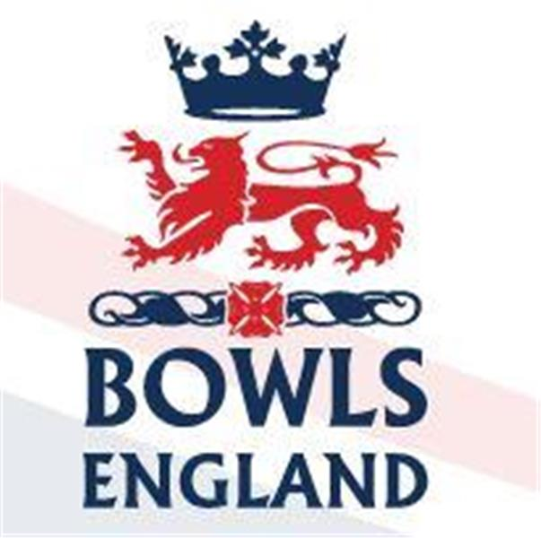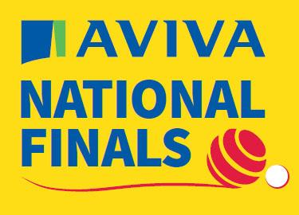
10th August to 27th August 2023 – Leamington Spa, Warwickshire.

Day 10 Review

Men’s Fours

Middlesex “A” Luke Mann, Joe Lovett, Mark Smith and Matt Larman started their path on A3 against Tony Forsdick, Vinny O’Neil Snr, Sean O’Brien and Vinny O’Neil from Middlesborough, Yorkshire. Vinny Jnr is a former Senior International who was Singles runner up in 2015. This season he has qualified in the Champion of Champions, which he had to concede, main singles which he lost to Sam Tolchard and 2 woods.

Ashford started the game solidly and were a couple in front early doors. Keeping up the momentum they opened up a 4 shot lead at halfway. Then they played a couple of superb conversion shots both resulting in counts and before you knew it they were out of site and heading to round 2. The Yorkshire side shook hands with only 13 ends played and Middlesex 22-7 up. Impressive stuff

Middlesex “B” were out on E6, indeed the marks were on red and with the green running in line with the main road they could not have been further from the clubhouse short of crossing the road and playing in the park. Steve Skinner, Stuart Phillips, Chris Harris and Tony Waller from Ladygate had drawn Nick Wardle, Jonathan Green, Chris Moore and Joe Dawson from Kingscroft, Leicestershire.

Nick and Joe had already had quite the week winning the National Pairs title on the last bowl of the extra end. Nick had also qualified in the Singles, Jonathan the 2 woods and Champion of Champions and Joe the mixed pairs.

The Ladygate four got off to a slower than slow start, struggling to find line and length on the tricky E green. After 4 ends they were 0-11 down. By half way they had pulled a couple back but were still behind the 8 ball. A couple of good ends, including a count of 4, pulled them back to within 6 but they never got closer and eventually shook hands at 17 ends 11-18 down. Not what they were hoping for even with the quality of the opposition.

Elsewhere in round one Wayne Wilgress’s Norfolk quartet got through as did Andy Knapper’s Berkshire side, Alistair Hollis’s Leicestershire side and Alan Price of Bucks. Casualties included Philip Broughton’s Stute four from Derbyshire, Paul Barnicott from Kent and Stephen Farish from Cumbria

Men’s Triples

This year there have been a series of classic finals and this triples game did not disappoint going right down to the wire. Eventually though Michael Gomme, Matthew Hyde and Andrew Briden from Gerrards Cross, Buckinghamshire pipped Simon Kittle, Steve Gunnell and Ed Morris of Essex County by the smallest of margins 15-14.

Poor Ed now has a flight to Australia for the World Championships to contemplate making 2 National Finals and losing them both by 1.

Mixed Fours

The final saw Chris Yeoman, Kayleigh Proctor, Rachel Cartwright and Simon Richardson from Northumberland play Chloe Brett, Rebecca Moorbey, Glyn Milbourne and Nick Brett from Huntingdonshire.

Chris Yeoman is a former Junior and Senior International. This season he has qualified in the pairs where he got through the prelim but lost 1st rd. In 2015 Chris won the family pairs and in 2013 he was runner up in the main pairs. Simon has this season qualified in the Singles where he lost 16-21, 1st rd to the eventual Champion. In 2011 he was runner up in the mixed fours. Kayleigh and Rachel both qualified in the triples and fours, losing 3rd rd in the triples and 2nd in the fours.

Chloe and Rebecca are both Junior Internationals. This season they have both qualified in the Junior Singles, Junior Pairs, Main triples and fours with Rebecca adding the main singles to that list. Last season Rebecca won the Ladies Singles and Junior Singles titles and with Chloe she won the Junior Pairs in 2021. Nick Brett is a member of the World Championship Squad about to head to Australia. He won the Singles in 1999 and the pairs last year.

The final was yet another high quality game but in the end the Northumberland side took the title 21-17.

Ladies Senior Pairs

The quarter finals of the Ladies Senior Pairs saw Linda Churchman and Cheryl Salisbury of Cambridgehsire beat Carol Watson and Sue Wilmott of Sussex 16-10; Sue Woollams and Sue Allen of Yorkshire went through 21-12 against Valarie Ford and Diane MCCullough of Gloucestershire; Margaret Smith and Teresa Orris of Surrey beat Wendy Holloway and Moira Parsons of Warwickshire 18-11 and finally Jane Cockrill and Frances Hendrick of Norfolk ended the hopes of Lynn Orlando and Helen Moore from Berkshire 22-13.

This meant 2 high quality semis to be played at 1230. In the first the Cambridgeshire ladies faced Yorkshire. Cheryl and Linda are a long established and successful pair having been National Pairs runners up in 2015. This season Linda has qualified in the pairs and Senior fours with Cheryl who herself has also qualified in the Singles and Triples. The two Sue’s also have decent records Sue Woollams has qualified for this year’s triples, Sue Allen the Senior Singles, main singles, 2 woods and pairs. Sue A was 2018 Senior Singles Champion, in 2021 was mixed pairs runner up and in 2022 Champion of Champions Runner up. With so much quality on display a tight game was expected but Cambridgeshire ran away with it 19-9.

In the second Surrey faced Norfolk. Teresa Orris has also qualified in the 2 woods. Margaret is a former Senior International who won the 2 woods in 2015 and the triples in 2018. She was runner up in the Pairs in 2021. This season she has qualified n the Senior Singles and Triples. Jane and Frances were the most inexperienced of the four pairs and it showed as Surrey took them apart 26-8

The final at 1530 was played on B1 due to the John’s Trophy on A Green but it still produced a great game. In the end Linda Churchman and Cheryl Salisbury added the Senior Pairs to their list of titles winning 13-10.

Men’s Senior Pairs

In today’s Semi Finals Michael Jeffs and Phillip Gladden from Oxfordshire pipped Colin Allen and Keith Butler from Cornwall 18-16 and Joe Festa and Phillip Russell from Hertfordshire beat Andrew Siely and John Colcombe from Norfolk 20-14.

The final was a totally one sided affair with Joe Festa and Phillip Russell running away with the title winning 27-3. Interesting that the official photo for the winners shows Jerry Rumball but the results have Festa playing every round, wonder if Bowls England actually know who is doing what.

Johns Trophy

The John’s Trophy Semi Final’s were both great affairs going right to the closing stages as befitting of such a stellar cast list of players. In the end Surrey gained revenge over 2022 Champions Lincolnshire 118-114 and Devon got past Essex 123-117.

The final was a high quality game of bowls across all 6 rinks. Ebbing to and fro the game was in the balance right until the end. At that end Devon were Champions for 2023 beating Surrey 116-110.

Day 11 Preview

Ladies Singles

The start of the Ladies singles is spread throughout the day and riddled with Diary / Programme confusion.

Middlesex “A” is Tonia Gann from Brentham BC. She is listed as playing Devon “B” at 1000hrs on A2. In the programme Devon “B” is Sue Evans from Honiton but in the draw it is Liz Smerdon from Crediton.

So, we have decided to go with a programme misprint and profile Liz! As well as the Singles Liz has this year qualified in the fours, Senior Pairs and Champion of Champions. She is also part of the Devon John’s Cup Squad. In the fours and Champion of Champions Liz lost first game, in the Senior Pairs she did not contest her game conceding to the opposition, no idea why. Liz is also a former Senior International.

Middx “B” is Cathy Taylor from Cambridge Park. Cathy gets a wait before her 1st rd game as she plays Carole Campion of Banbury Central, Oxfordshire but not until 1500 on D2.

This season Cathy also qualified in the fours and Senior Fours with the later still to be played. Carole also qualified In the fours, losing first round and the triples where she lost 2nd round to her own County. Carole is a former Senior International and has won the National Triples in 2008. She was runner up in the Champion of Champions in 2012 and in the now defunct Mother and Daughter pairs in 2003.

The Ladies Singles 2nd rd is at 1000hrs on Monday morning.

Men’s Fours

The 2nd round of the Men’s Fours kicks off at 1000hrs with Middlesex “A’ Luke Mann, Joe Lovett, Mark Smith and Matt Larman from Ashford on C1 to play Trevor Skinner, Keith Hysted, Chris Fitzgerald and Geoff Gough from Chatham in Kent. The Kent lads enjoyed a 1st rd romp early on Sunday as they beat Surrey “A” 24-5.

Victory will see round 3 at 1400 Sunday.

Other games in round 2 Keith Holman’s Lindfield, Sussex team face Nick Jones of Boscombe Cliff, Hampshire. Andy Knapper and team play Jamie Holmes Kings Chase, from Essex and Triples Champion Andrew Briden get’s his campaign under way against Tom Holmes from Herefordhisre.

Balcomb Trophy

The Balcomb Trophy is a 2 rink inter County Competition, supposedly for the Best 8 in each County. Much like the mixed fours however it is beset with issues surrounding player clashes with the Men’s Fours going on at the same time.
The Semi Final draw at 1000hrs see Buckinghamshire play Essex and Cumbria play Wiltshire. The final is on A green at 1400.

