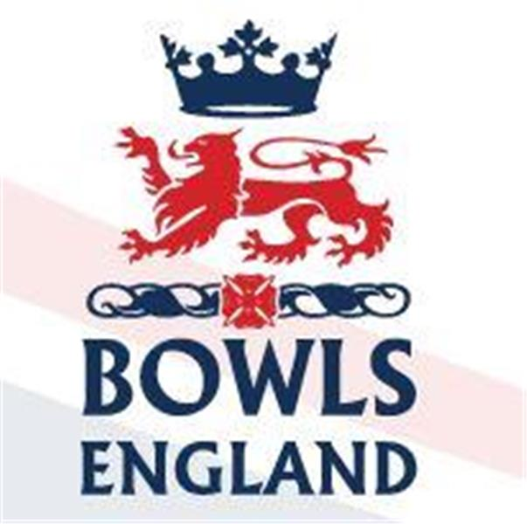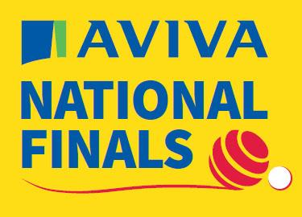
10th August to 27th August 2023 – Leamington Spa, Warwickshire.

Day 3 Review

Well we are here and we spent the day watching some great action across a number of semi’s and finals. Let’s start with the two previews we forgot yesterday.

Amy Rose Bowl

A Double rink Competition for Ladies Under 31.

In the Semis the two power houses of the Ladies “Junior” game came through unscathed. Devon slaughtered poor Durham 56-16 and only played 12 ends. Kent “B” had to work harder but got past Leicestershire 48-33.

In the final Kent brought in 2 players who had lost in the Semi final of the fours (spoiler). Squad game I guess but it must have been hard on the 2 players who played in the Semi even though we were told they knew it would happen in advance.

Any way Kent got off to a storming start and were comfortably ahead but the Devon experience started to show through and they fought right back to take it to the last wood. Sophie Tolchard played a running bowl and narrowly missed meaning Kent retained their title by 1 shot.

White Rose Trophy

A Double rink competition for Men under 25, makes you wonder why the 2 sexes don’t play to the same rules but hey ho!

In the Semi’s Kent overcame Cumbria 46-34 and Cambridgeshire beat Gloucestershire 46-31.

In the final Kent again made the running and at one stage looked to be running away with it but Cambridgeshire fought back and again took the game down to the last end. The quality of the bowls being played by some of these youngsters was stunning and bodes well for the future of the game.

On the last end Cambridgeshire needed 2 but they couldn’t quite get the result they needed from their running bowls and Kent triumphed 46-41.

This meant Kent completed the Junior double for the second successive year.

Tony Allcock Trophy

Late last night in a darkened cupboard habituated by an overworked underpaid Bowls England staffer they decided that Old Coulsdon, Surrey had in fact beaten Cove in the quarters.

Old Coulsdon took advantage of this administrative reprieve and thumped Norfolk in the Semi’s 33-9 with Norfolk conceding with only 12 ends played. In the 2nd Semi Torquay “A” beat Leicester 36-28.

The final was nip and tuck all the way with barely a shot between the sides on either rink. As the end approached Torquay managed to just get their noses in front enough to secure the title 43-39. It’s not as if nothing else goes to Devon is it!!

Club Two Fours

Well another of Middlesex’s overseas emissaries has a National Title!

In the Semi finals New Lount, Leicestershire beat Worcester 37-24 without one of their key players, more on that later. Shanklin, from the Isle of Wight overcame King’s from Devon 38-22 in an impressive display with the rink of Travis Mellor putting Jamie Walker’s four to the sword.

In the final Shanklin started the better but New Lount fought back. Into the later stages Shanklin still held sway with one rink well up and the other down but not by as much. Into the final end and Shanklin led by 2. Delay after delay as the two rinks tried to watch the other close out to decide what to do on the other. As it turned out the New Lount skip on their losing rink took his own bowl out with his final bowl to hand Shanklin 2 shots and a four shot lead. Although down on the other rink it was not by enough and Travis Mellor did not bowl his last wood. Shanklin were national champions 34-31.

Playing two on Travis Mellor’s rink a certain Ron Le Leux!

Family Pairs

The timings of the family pairs Semi’s and final seemed strange, almost as if the comp didn’t matter. Semi’s starting as the other comps finished and everyone wandered off for lunch and the final starting with the Ladies fours final well under way along side.

That said the quality of the bowls on the rapid A green was lovely to watch as the partnerships showed how much success with a family member meant. In the 1st Semi George and Richard Reid were always up against it, the pair from Gerrards Cross were probably not helped by club mate Tom McGuiness being on the next rink. Michael and Neil Corbyn from Northants, though, took full advantage and moved into the final 21-12.

The 2nd semi saw Christopher and Nicholas Pearce from Somerset 6 down into the closing stages. They fought back to take the game into the final end all square at 13 all. Mark and Paul Sturtridge from Cornwall got the vital shot to go through.

In the final it was a tight affair but the trophy will be heading down to the West country with the Sturtridge’s winning 16-14.

Ladies Fours

It’s probably a good job that I only make and write notes on these events and that I don’t make wagers to back my opinions or I’d be even more skint than I am.

Having highlighted the disparity in the records of the four Semi finalists the 2 heavy weights both promptly lost. Kent 11-18 to Berkshire and Oxford 11-17 to Surrey.

In the final Berkshire got off to a good start and took a good lead but Surrey pegged them back shot by shot. Eventually it went down to a nail biting last end, which given the talons on some of the young ladies might have been a dangerous and expensive activity. Eventually Jemma Tuohy, Yasmina Hasan, Elizabeth Anderson and Debbie Souter won by the narrowest margin 18-17.

The victory for Elizabeth and Debbie came 6 years after they lost the 2017 final to Middlesex. Jemma Tuohy, is the daughter of ex Middlesex players Steve and Helen Tuohy. This, we believe, is her first competitive season bowling and she has a National title, something in the genes there!
Men’s Singles

So we finish with what many consider to be the Gold Ribbon event.

In the quarters Darren Allsopp of the New Lount BC, Leicestershire beat Chris McGready of St Georges Dragon, Northumberland 21-12. Great for Darren, obviously but his success was taking one of the New Lount’s key players out of their double four team. Surely these clashes are something Bowls England have to continue to look at through their working party, squad game or not.

John Rednall of Felixstowe and Suffolk ended Barry Hopkin’s run with the Durham player losing 19-21 in a close game. Simon Jones of Reading, Berkshire led early against Tom McGuiness of Gerrards Cross, Bucks but Tom fought back and progressed 21-17. Finally Lewis King from Appleyard, Kent beat Richard Maule from Vines Park, Worcestershire 21-12.

Onto the Semi’s Darren faced the vastly experienced Rednall. John retired from International bowls in 2022 with over 100 caps to his name over a 35 year period, more caps than any other player. He won the Junior Singles in 1987 and there is a fair chance the other 3 semi finalists were not born? He went on to win the National Pairs in 2003 and the Champion of Champions in 2009. In 2013 he was runner up in the Singles. John made the better start and led early but once Darren found his range there was only one player in it and although John closed the gap late on Darren won with room to spare 21-9.

The other Semi saw Lewis take on Tom. Tom is a rising star of the game and part of the recent Under 25 success at the British Isle Championships. With his dad he won the 2017 family pairs and he was part of the 2019 fours champions before again making the fours final in 2021 where this time he was runner up.

This was a much tighter game but midway Tom seemed to lose his line and pace, only slightly but enough to let Lewis steam through 21-16.

The final was a one sided affair with Lewis bowling superbly to take his first Outdoor national title 21-10. To see him in tears at the end, hugging his multi title winning mum Wendy showed how much it meant to him.

Day 4 preview.

Middlesex are back in action on day four as the Men’s Pairs and the Ladies triples start.

Men’s Pairs

On Rink A6 at the ridiculous time of 0900 on a Sunday Middlesex “A” Chris Harris and Tony Waller from Ladygate start their campaign against Wiltshire “A” Chris Cheesley and Mel Biggs from Westlecot.

Chris and Tony, of course, were part of the 2016 Triples runner up but their success pales when compared to that of Mel. 1st Selected as an England International in 1987 Mel has won the pairs (1995), Fours (1997), Triples (2005), Senior Pairs (2013 and 2015) and Senior Fours (2017). This year he has also qualified in the triples.

Middlesex “B” Norman Worley and Glen Adam’s from Paddington start on E5, also at 0900, against Michael Newton and Anthony Roff of Iver Heath, Bucks. Glen is a former Junior and Senior International and past winner of the National Junior Pairs.

Victory will see the pairs back at 1700 to play the 2nd rd.

After the Men’s pairs have had their 1st rd the ladies start their triples campaigns

Ladies Triples

At 1300 on A5 Karen Ryan, Megan Hunt and Sue Butcher from West Ealing start their campaign against Sue Woollams, Lesley Dearlove and Helen Walker from Thirsk in Yorkshire.

Karen has had a great year also qualifying in the Senior Pairs with Sue and the mixed pairs with Paul Wilshire. For the opposition Sue Woollams has qualified in the Senior Pairs

Out on E5, also at 1300, the Broomfield trio of Brenda Burles, Janet Walby and Terri Watkinson can take some tips on line and pace from Norman and Glen before taking on Celia Morris, Hilary Sharpe and Billie Swift from Kingsthorpe, Northants.

Billie has qualified in the Junior Singles and Pairs

More tomorrow evening, timings will depend upon success!!

