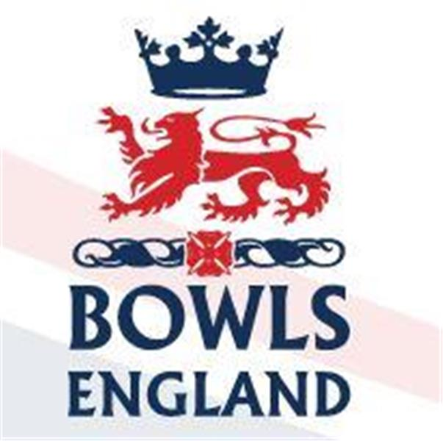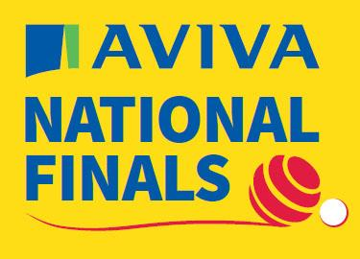
10th August to 27th August 2023 – Leamington Spa, Warwickshire.

Day 18 Review

Men’s Senior Singles

Quarter Final time and on A Green 2023 Men’s Champion of Champions winner Roger Ashby from Nuneaton, Warwickshire beat Stephen McAlister from Gerrards Cross, Bucks 21-16. Steve Poyner of Vines Park, Worcestershire got past Clive Burnham from Gravesend, Kent 21-13.

Out on D green Chris Hanslip from Blossom Way, Lincolnshire continued his fine form as he beat Robin Waterhouse from Newmarket Avenue, Cambridgeshire 21-7. This game was curious as both players played every wood on the inside hand, irrespective of position at the time. They never bowled a ditch hand wood at any point except the trial ends. The other quarter final was a classic with some superb bowls being played by both players. In the end it came down to a last end shoot out, both due to the score and the fact that they were out of time. Mike Owen from East Leake, Nottingham pipped Howard Wattts from Headington, Oxfordshire 21-20 in a game that warranted a wider audience than the dozen or so gathered watching.

Semi final time and Graham faced Chris, with both players previously profiled it was straight into the action on D4. Chris started well but Graham fought back and then he started producing end after end of quality drawn bowls to move away and win 21-11.

In the other Semi Steve, who had also qualified in the 2 woods faced Michael who was part of the Notts side that won the fours in 2002. It was nip and tuck for a long time but slowly Steve’s more consistent drawing him saw him pull away to win 21-13.

The final. Would Graham Ashby take one step further than he had in 2022 and win the title. Well no, Steve found the pace on the slower B green really well and completely outplayed his more experienced opponent who grew increasingly frustrated about not getting the pace. It turned into a cake walk as Steve took the title 21-3!

Ladies Senior Singles

D green hosted all the Ladies quarters. On D5 Sue Allen from Swinton, Yorkshire romped past a shell shocked Sylvia Bloomfield from Harlow, Essex 21-4. Gillian Barnes from Boxford, Suffolk won the battle of the Gillian’s beating Gillian Hill from Eastbourne, Sussex 21-16. Sue Cooke from Box, Wiltshire led early against Margaret Smith from Sutton, Surrey but was eventually over hauled 15-21. The last quarter saw Kate Kyle from Shepshed Town, Leicestershire beat Debbie Roe from Stotfold, Bedfordshire 21-16.

The semi’s were also on D Green and in the first Kate played Margaret. Kate was profiled before playing Karen and Sue in the Senior Pairs but her opponent Margaret was a previous National triples winner and a Senior International as recently as 2018. As it turned out none of that mattered as on the day Kate was more clinical winning 21-13. The other Semi was much more dramatic. 2018 Senior Singles winner Sue played Gillian. Gillian opened up a nice lead and looked to be heading into the final but Sue hung in there and twice saved game with her last bowl. With the scores locked at 20-20 Sue held 2 including the shot which was in front of the Jack and virtually touching it. With her third bowl Gillian got a glide off of both her side bowls to settle on the jack from the side but touching it. Sue looked less than impressed at the good fortune and found herself game down again. With her last wood she played a foot over the weight, hit her now 2nd wood and turned Gillian’s bowl away for game 21-20. A superb conclusion and great scenes from Sue’s family just along the side from where we were sat.

So final time. Sue led early but Kate battled back well and took the lead. Much like her Semi sue found herself having to play catch up but this time when she missed Kate pounced securing a last end 3 to win 17-21 and take the title to Leicestershire.

Walker Cup

It was pointed out to me after yesterday’s blog that the Walker comp is a Cup not a trophy!

In the Semi finals there were two starkly contrasting games. In Semi 1 of A Green Norfolk walked all over Cornwall and the game was over 51-20 after only 18 ends. This would be the first time since victory in 1991 that Norfolk had made the final. Cornwall would have to wait another year to improve on their last final in 2001 and last victory in 1993.

In the other Semi on A5 and A6 Berkshire took on 2019 and 2021 Champions Lincolnshire. Berkshire have never won the title and made the final in 2008 for the only time. For most of this game it looked like Berkshire would make the final but Lincolnshire clawed it back to take the tie to an extra end. Nerves were shredded amongst both the players and the big Berkshire support in the small grandstand but in the end Lincolnshire got the shot and a place in the final 37-36.

The final was on B green due to the Middleton Cup. The early stages were very tight across the 2 rinks with Norfolk pulling ahead on one rink but Lincolnshire the other. As the game moved into it’s mid section Norfolk moved ahead by virtue of their winning rink getting away. The last few ends saw Lincolnshire fight back on that rink and in the end they only lost by 2. On the other rink Lincolnshire got half a dozen in front and stayed their holding Norfolk at bay. Norfolk went into the last end needing four but they couldn’t get them and actually lost a single. So Lincolnshire took the title 32-27.

Middleton Cup

C green saw the Semi between Lincolnshire and Huntingdonshire. Lincolnshire won on 3 rinks with the main damage being done by Dominic McVittie’s rink winning by 20 over Eon Morton. Huntingdonshire replied with two rink wins and a tie but they were not by big enough margins to over turn the overall and Lincolnshire were through 106-95

Warwickshire took on defending Champions Berkshire on B green. Each county won on 3 rinks but the bigger wins were for Berkshire who progressed 121-113.

So the big one, the 2023 Middleton Cup final on A Green. Lincolnshire v Berkshire. The game swung to and fro but the master board always had Lincolnshire slightly in front. As the closing stages approached Berkshire narrowed the gap to single figures. The noise got louder and louder as big shots were played and heads turned over. Berkshire shouted rallying cries, Lincolnshire cheered every single shot gained. Then the rinks started to finish. J West beat Robert Newman on A1 by 5 shots but Dominic McVittie went down by 12 to P Hulbert. Martin Spencer beat BJ Byles by 2 as A Bird lost by 3 to N Jones. Jordan Philpott beat R Buckett by 2 shots so with one rink left Berkshire held a 6 shot lead on paper. Trouble was bowls does not follow a nice neat pattern as outlined above and everyone could see the score on rink A6 where the rink of Berkshire’s Mark Hancock was going down heavily to C Barks. In the end that rink finished 32-9 and made the difference as Lincolnshire took the title 115-98. Berkshire will not be taking rink A6 back down to the royal county as it cost them in the Walker and Middleton.

Congratulations to Lincolnshire champions for the first time since 1996.

Day 19 Preview Bank Holiday Monday

Shopping, tidying, football, life goes on!!!!!

