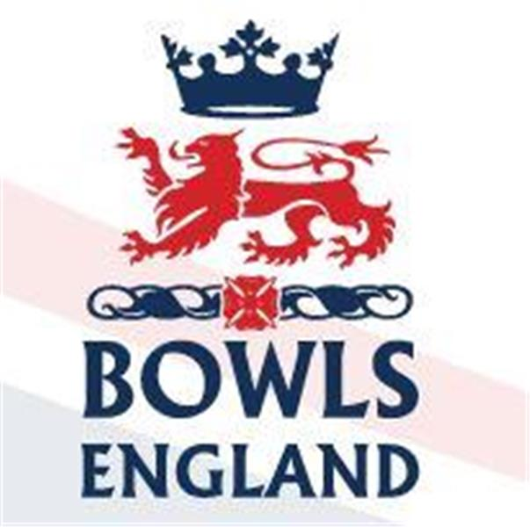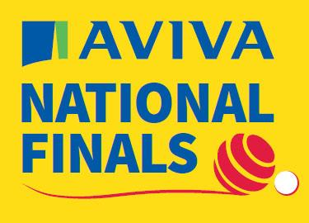
10th August to 27th August 2023 – Leamington Spa, Warwickshire.

Day 16 Review

Men’s 2 Woods

The Quarters saw the end of the road for Ashley Tanner’s conqueror Harry Godwin from Appleyard, Kent as he lost 13-16 to Kyle Anderson from Royal Wootton Bassett, Wiltshire. Mark Ireland from Avenue BC, Coventry, Warwickshire saw off Mark Bishopp from Egham, Surrey 16-12. The all Hampshire battle went the way of Alan Geary from Boscombe Cliff who beat Peter Ward from Ringwood 16-13 and the final quarter saw Mark Nullmeyers from Romford, Essex beat Stuart Holland from Spartan and Lakeside, Sussex 16-13.

The semis saw Mark Ireland who also qualified in the Mixed Fours take on Kyle Anderson who had reached the 3rd rd in this year’s triples and also played in the fours. In 2018 Kyle was part of the National Fours Champions. On the day Mark was too consistent for Kyle winning 17-6

The 2nd Semi saw former Junior International and 2010 Junior Singles winner Mark take on Alan. Mark also won the 2017 Mixed fours but Alan took him all the way to an extra end which he won.

So the men’s final Mark v Alan and it was Mark who will take the trophy the short journey back to the Avenue Club, Coventry winning 16-10.

Ladies 2 Woods

Quarter final time. At 0930hrs Shannon Maughan of Bletchley Bc, Bucks caused an upset beating multiple Commonwealth gold medallist Sian Honnor from Appleyard, Kent 15-12. Katherine Hawes-Watts from Oxford City and County had reached the quarter finals by winning an extra end shoot out, in her quarter final she suffered the opposite emotion as she lost on the extra end 15-16 to Rebecca Wilgress of Norfolk BC. The 3rd quarter final also went to the extra end. Laura Holden of Clevedon, Somerset pipped Linda Rose on Whitehaven, Cumbria 13-12. Finally defending Champion Rhianna Russell from Welwyn & District saw off Susan Forster from Houghton Dairy Bc, Durham 16-9.

Semi final time and Shannon who had also qualified in the Junior Singles and Pairs saw of Rebecca Wilgress 15-6. The 2nd Semi finally saw the end of her title defence for Rhianna as she lost 9-18 to Laura.

So the final. Relative experience against relative inexperience. Laura is a past Junior International and a current senior one. She won the Junior Pairs title back in 2010 and this year had qualified in both the triples and fours alongside club mate and new singles champion Stef Branfield.

Shannon started well and was not over awed by Laura. Slowly though Laura reeled Shannon back in and once in front she took the title 17-10

Men’s Top Club

It was the quarter finals of the Men’s Top Club today and there were some cracking ties across the 4 greens used.

On B Green Headington, Oxfordshire took on Darlington Railway Athletic, Durham. Darlington took the 2 woods on a dramatic extra end and then added the singles. Headington took the Pairs by four and the triples by 1 so the deciding element would be the fours and Darlington took that to progress 3-2.

On C Green Appleyard, Kent faced Reading Berkshire. There were no tight games here but the match still finished 3-2 overall. Appleyard secured both singles but Reading responded with the pairs and triples. The deciding fours went to ….Appleyard.

D Green and the only game that did not go 3-2. Sandy Conservatives (Bedfordshire) took the Triples against Shaldon, Devon but the Devonians took the other 2 elements even if in the case of the Pairs and fours it was by only 2 shots.

Finally out on E Green the new Club Double Fours Champions Shanklin from the Isle of Wight set out on the path to winning the double. Their opponents from Lincolnshire, Brampton BC took the Singles but Shanklin responded with the 2 woods. Shanklin then took the Pairs but Brampton replied with the fours. 2-2 and the triples left which was won by…. Shanklin and they move on 3-2.

Ladies Top Club

The ladies event is slightly different with no 2 woods and aggregate score coming in to play if each side wins 2 elements.

On E Green there were no such concerns as Appleyard, Kent dominated Oxford City and County, Oxfordshire winning 4-0.

D Green was much tighter. Egham, Surrey won the fours by 1 and the triples by 2. Kingscroft, Leicestershire responded by taking the Pairs by 2. So could Kingscroft win the singles and take it down to aggregate, well no they couldn’t with Egham winning 21-16 and progressing 3-1.

On A Green there was the big clash between Kings, Devon and Norfolk, Norfolk! Kings won the singles but were well beaten in the Pairs. Kings won the fours so it was down to the closely contested Triples game. Eventually it was a 2 shot win to Kings and progress to the Semis 3-1.

The tightest game was on B green between Wigton, Cumbria and Royston, Herts. Royston narrowly won the singles but Wigton replied by narrowly winning the Pairs. Wigton then had a comfortable win in the triples leaving Royston needing to win and win well in the fours. Well they did just that. A 15 shot victory tied the match at 2-2 and gave them the tie 69-67 on aggregate.

Day 17 Preview

To nick a strictly concept tomorrow at Leamington is Movie Week and Middlesex will be portraying the Lady and the Tramp !

Men’s Senior Singles

At 0930 on D5 Attilio Ciampini from Uxbridge begins his bid to become Senior Singles Champion. He takes on Chris Hanslip from Blossom Way, Lincolnshire.

Chris qualified in the fours where with his clubmates he lost 2nd rd, he is also part of the Lincolnshire Middleton Cup squad due to play on Sunday in the last days Middleton Cup Semi’s

Victory for Attilio will see him play again at 1430 on C5 against the winner of D6 which could be Roy Spencer, an ex Middlesex player now in Surrey.

Ladies Senior Singles

At 1430hrs Hannah Hollis of Bush Hill Park becomes the last Middlesex player to start their competition for 2023.

On E1 Hannah takes on Sandra Aldridge of Ryde Marina, Isle of Wight. It has to be said Sandra has enjoyed a decent Championships to date. Having qualified in the triples she made the quarter finals where they lost to the eventual winners from Devon. She also qualified in the Senior Fours where they didn’t lose to anyone, winning the title!

Victory for Hannah will see her play again at 1730 on D4.

Men’s Top Club

At 0930 on D Green, where in theory I will be watching (see earlier) Darlington Railway take on Appleyard.

On B Green at the same time Shaldon take on Shanklin. Shanklin have twice previously been runners up in 2010 and 2012.

Whatever the Semi final outcomes a new Top club will be crowned when the final is played on A green at 1500.

Ladies Top Club

The Ladies semis at 0930hrs see Appleyard take on Egham on A green and Royston take on Kings on C green.

Appleyard were runners up in 2021. Egham were runners up in 2013 before moving up a step and winning the title in back to back years 2014 and 2015.

Royston have never won the title and they face Kings who have won the comp for the last 4 years!

The final is on B green at 1500.

Can Kings make it 5 titles in a row or will Appleyard do the double and win both Men’s and Ladies titles.

More tomorrow

