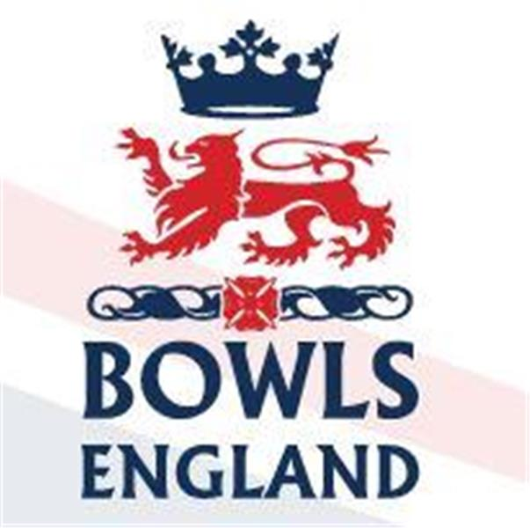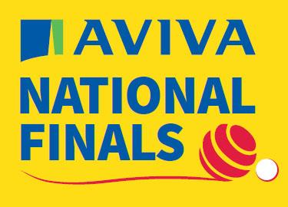
10th August to 27th August 2023 – Leamington Spa, Warwickshire.

Day 11 Review

Ladies Singles

First up this morning was Middlesex “A” Tonia Gann from Brentham BC. At 1000hrs she was drawn to play Liz Smerdon of Crediton BC, Devon on A2.

Now Tonia, has without doubt hit the ground running in her bowls career. Her quality and success, to date, are perhaps remarkable given how short a time she has been playing the game. Her opponent Liz however is at the other end of the experience spectrum having been a Senior International from 2008-2011.

Sadly I was not able to attend as planned today and the information on the live scoring portal is about as useful as a chocolate fire guard and updated as regularly as Spurs trophies come along.

The only updates I received were that Tonia was 4-6 down and that the rink was very tricky. The phrase first in won seemed to be the order of the day and Liz was doing that more regularly that Tonia. Next update on the Portal Tonia was 10-19 down and although she pulled a couple back Liz saw out the game 13-21. A great effort from Tonia and I have no doubt we will be seeing a lot more of her competitively at the Nationals in years to come.

Middlesex “B” was Cathy Taylor from Cambridge Park. Cathy of course has a National Title to her name having been part of the fours champions in 2017. Her opponent on D2 was Carole Campion from Oxford City and County who also has a National title to her name, the triples from 2008.

A good game was anticipated and so it proved. Early word was Cathy was 6-4 up, shortly after 8-5. Cathy then lost a 3 but picked one back up the next end to lead 11-9. The last update we got was it was 12-10 to Cathy and then Radio Silence. Everyone had gone off to watch the drama unfold in the Men’s Fours, more on that later!

When coverage resumed Cathy was 18-19 down but has a chance to lie 3 and lay game. It didn’t happen and before you knew it it was 20-20 and everyone was looking at their watches as they were the first game I know of to be approaching the time limit. The last end unfolded, slowly and when the last bowl had been played Cathy had shot and a great win 21-20.

In other 1st rd games defending champion Rebecca Moorbey from Huntingdonshire progressed 21-4, 2021 Champion Stef Branfield from Somerset won 21-7 over Cheryl Salisbury from Cambridgeshire who won the Ladies Senior Pairs yesterday. Another past Champion Kirsty Richards from Warwickshire won 21-18 and Annalisa Dunham from Lincolnshire is through 21-9. Donna Grant from Oxfordshire, who won the Pairs yesterday lost 14-21 and Rebeeca Wilgress from Norfolk who won the mixed pairs lost 20-21 to
Teresa Newman of Berkshire.

Men’s Fours

Ok, here we go eyes down for a bumpy ride!

Middlesex “A” Luke Mann, Joe Lovett, Mark Smith and Matt Larman from Ashford BC stormed into day 2 yesterday with a 22-7 win. Today on C1 they played their 2nd rd game against Trevor Skinner, Keith Hysted, Chris Fitzgerald and Geoff Gough of Chatham, Kent.

The first update on the live portal was after 11 ends had been played and it was great to see that Ashford were 12-10 up. They maintained that control and by 14 ends had opened a 6 shot gap at 16-10. Kent pulled a couple back but Ashford still went into the last end with a 4 shot lead. As the head built up Kent had the chance to make 4 until Mark trailed the jack leaving the Kent skip with an almost impossible shot. He didn’t make it and Ashford were into the 3rd rd 18-15.

Elsewhere in round 2 Glenn William’s Garston four went out 14-15 no doubt moaning about the green, James Amery’s Somerset four progressed 18-9 at the expense of Northumberland, Andrew Briden continued to ride his wave of success wining 17-15 and Andy Knapper’s four knocked out Jamie Holmes. Ladygate’s Conquerors Leicestershire A beat Leicestershire B 21-5 in 14 ends.

In the 3rd rd, at 1400 on A2 Ashford would play John Tufts, Richard Summers, Ian Catchpole ad Wayne Willgress from Norfolk BC. They had progressed into round 3 by beating Oxfordshire 21-18 and Hertfordshire 22-6. Ian and Wayne have been profiled as part of the mixed events in previous days. John Tufts was Wayne’s lead when they won the Pairs in 2021.

Norfolk took the opening Single but at 4 ends it was nicely situated at 3-3. Then Norfolk started to take control, Ashford were bowling well but Norfolk were bowling better and getting the rub at that point. Wayne Wilgress drew 2 shots to an off centre jack, Norfolk won a measure and slowly but surely they opened up a 3-17 lead.

Ashford won the next end and got control of the Jack, at 11 ends they were back to 8-17 and then they took a fantastic 5, game on and momentum with the Ashford boys who can be hard to stop when they get rolling.

13-17 became 15-17 on the 13th but then Norfolk got a double. 4 down, 4 to play. Would the experience on the Norfolk boys hold sway or would the noisy crowd drive Ashford on. 17-19 at 15 became 19 all at 16 as Matt Larman took a Norfolk bowl clean out of the head. A 3rd double and Ashford were 2 up playing the final end. Norfolk could not get what they needed, Ashford took the shot and they had recovered from 3-17 down to put out a star studded four 22-19. Que scenes on and off the green as everyone celebrated.

Breathless and I wasn’t even there!!

Elsewhere there were some tight games. Lancashire beat Isle of Wight 12-11, Briden’s Gerrards Cross four went through 15-12 and Alan Price’s Gerrards Cross four won 16-15 over the Morton’s of Hunts. Joe Dawson’s Leicester four roll on winning 21-10. Knapper’s Berkshire four, however, are out beaten 5-19 by Barry Hopkins and his Durham four.

Balcomb Trophy

There was one relatively tight Semi final with Cumbria beating Wiltshire 40-34 and there was one extremely tight, squeaky bum time semi final with nails bitten down to the quick which saw Essex beat Buckinghamshire 37-36.

In the final, 2017 and defending Champions Essex showed determination to hang onto their silverware and so it proved as they beat Cumbria 45-36 to cue wild scenes of celebration.
Disability Bowls England Pairs

Congratulations to Steve Stockley, formerly of Parsons Green and a long time servant of Middlesex Bowls who having been through some tough times with his health today won the DBE National Pairs title with his partner Mike McDonagh 29-11. Inspirational stuff

Day 12 Preview

Ladies Singles

Round 2 sees Cathy face Suzanne King from Norfolk BC at 1000hrs on C5. Suzanne got through her 1st rd game 21-13 over Carole Wolton of Ryde Marina, Isle of Wight. Suzanne also qualified in the pairs where she lost 2nd rd.

Victory would see Cathy move onto A3 at 1400 possibly for a 3rd rd tie with Annalisa Dunham.

Other Interesting 2nd rd ties. Tonia’s Conqueror Liz Smerdon faces Penny Cresswell of Poole Park, Dorset; Sue Evan’s of Honiton, Devon faces Kirsty Richards and Jayne Christie of Potton, Beds faces Rachel Mackriell of Polegrove, Sussex

Men’s Fours

It’s quarter final time at 1000hrs. Stephen McAlister, George Reid, Richard Reid and Alan Price of Gerrards Cross, Bucks take on Nick Wardle, Jonathan Green, Chris Moore and Joe Dawson of Kingscroft, Leicestershire; Michael Gomme, Tim Godman, Mathew Hyde and Andrew Briden from Gerrards Cross, Bucks take on Colin Boston, John Lynch, Andy Kirkland and Barry Hopkins of Darlington Railway Athletic BC, Durham.

Therefore there is the possibility of an all Gerrards Cross National Semi or of the 2023 National Triples winners taking on the 2023 National Pairs winners.

In the other half Steve Hill, Harry Mycock, Dominic McVittie and Martin Spencer from Royal Mail Cart BC, Lincolnshire take on Nigel Williams, Grant Howland, Anthony Booth-Young and Robert Striling from Heaton Hall BC and finally the one we are all interested in Luke Mann, Joe Lovett, Marl Smith and Matt Larman against Kenny Muir, Willy McGinn, Alan Muir and Alistair Melville from Corby Forest BC, Northamptonshire.

The Northamptonshire lads have progressed 18-15 against Bedfordshire, 24-15 against Lincolnshire and 22-12 against Gloucestershire.

Ladies Senior Fours

The Competition starts Monday afternoon with 3 prelim ties, Middlesex though not directly feature in them.

Past Middlesex, however, do! Sue Bard-Bodek who won the mixed pairs with Kenny Allen in 1997 plays with her colleagues from the Borough of Eye BC, Suffolk against Potton BC,,Bedfordshire. The other 2 ties see Portishead RBL, Somerset play Wellingborough, Northants and Dukeries, Notts play Borough Green, Kent.

Men’s Senior Fours

The same situation applies in the Men’s as the Ladies with Middlesex having a bye but 3 prelim ties having to be played. Camberley BC, Surrey face Wymnodham Dell, Norfolk; Gordon Charlton’s Sandwich four from Kent face Wanstead Central, Essex and Blaby., Leicestershire face Plessey, Isle of Wight.

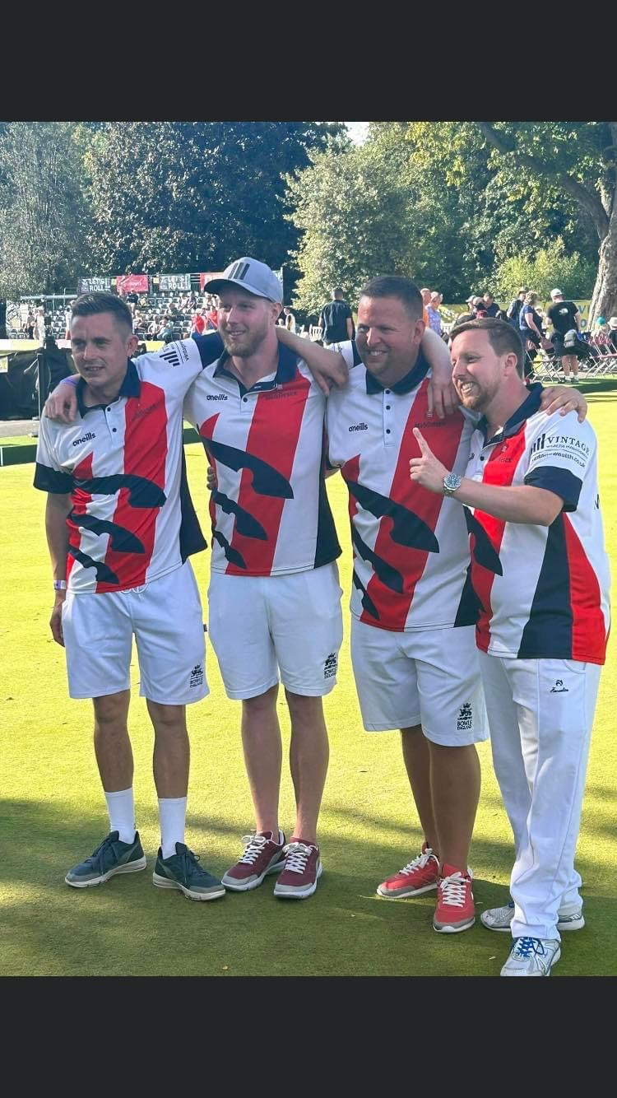
Photo used with permission of Julie Killick

